MODULE 2

PRACTICE 2.2:-

1. Using the Global Fast Foods database, retrieve the customer’s first name, last name, and address for the customer who uses ID 456

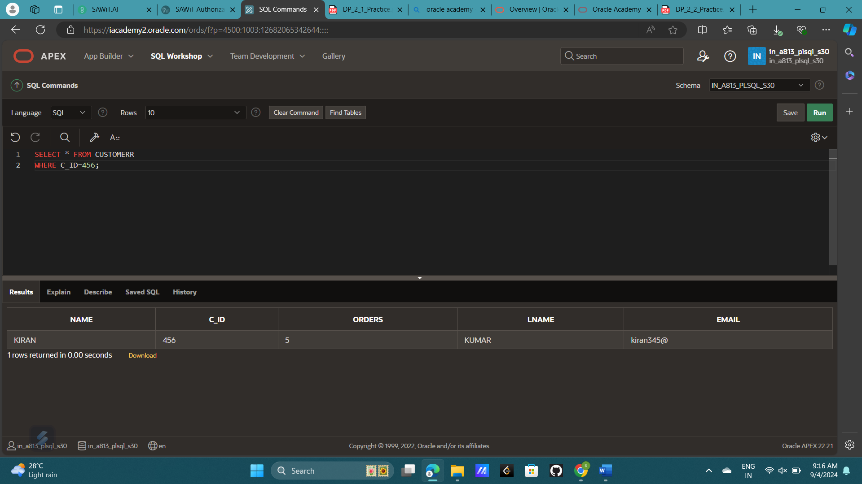

2. Show the name, start date, and end date for Global Fast Foods' promotional item “ballpen and highlighter” giveaway.

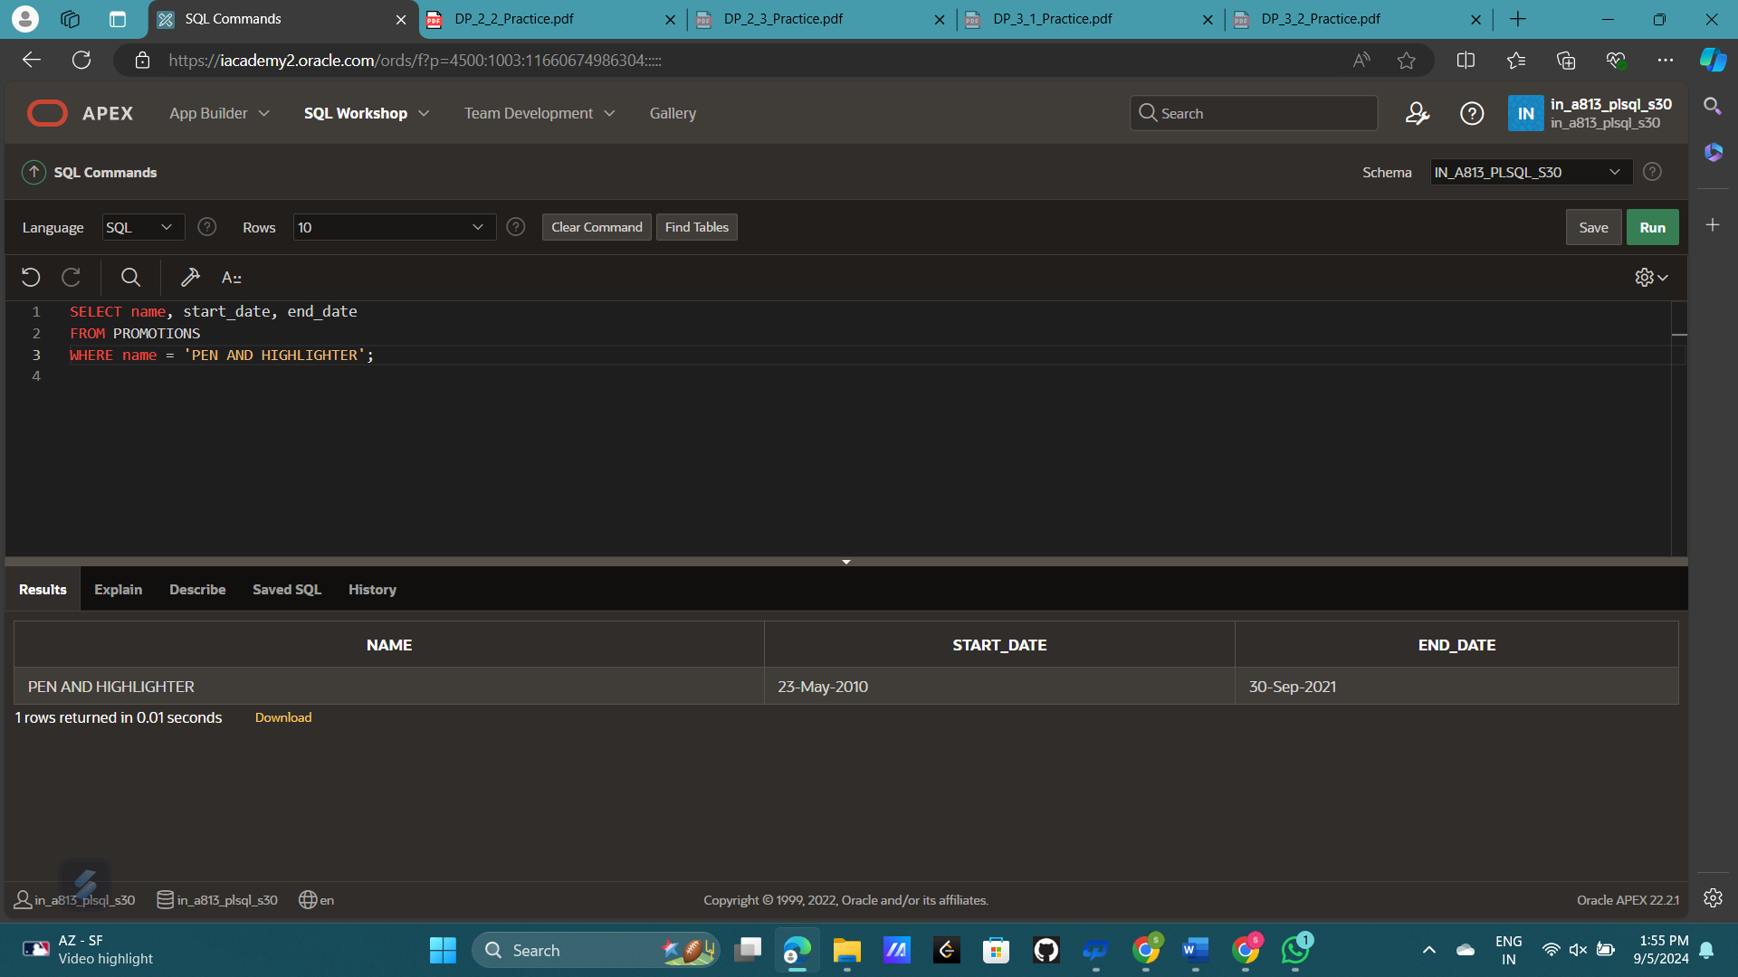

3. Create a SQL statement that produces the following output:

Oldest The 1997 recording in our database is The Celebrants Live in Concert

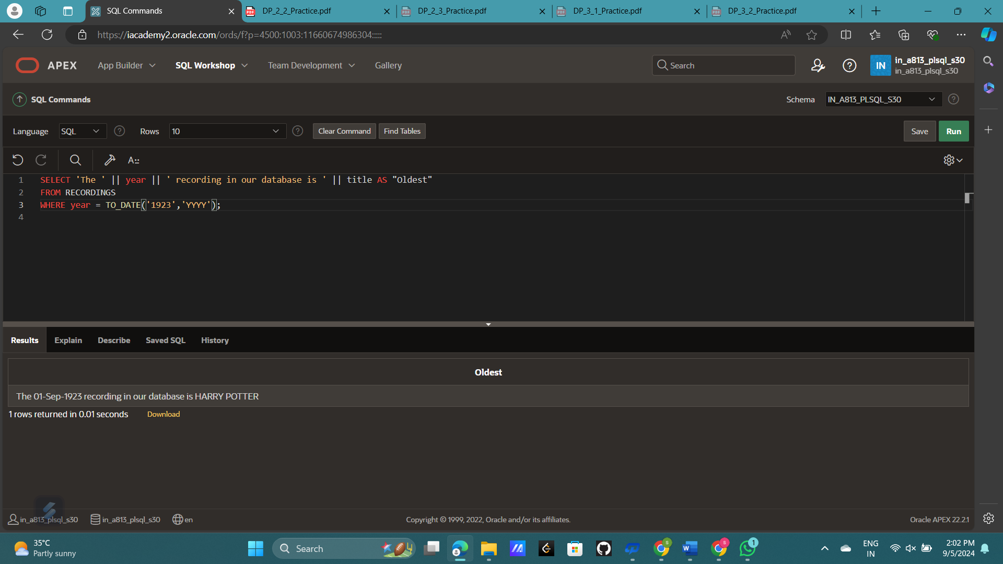

4. The following query was supposed to return the CD title “Carpe Diem" but no rows were returned. Correct the mistake in the statement and show the output.

SELECT produce, title FROM d_cds WHERE title = 'carpe diem' ;

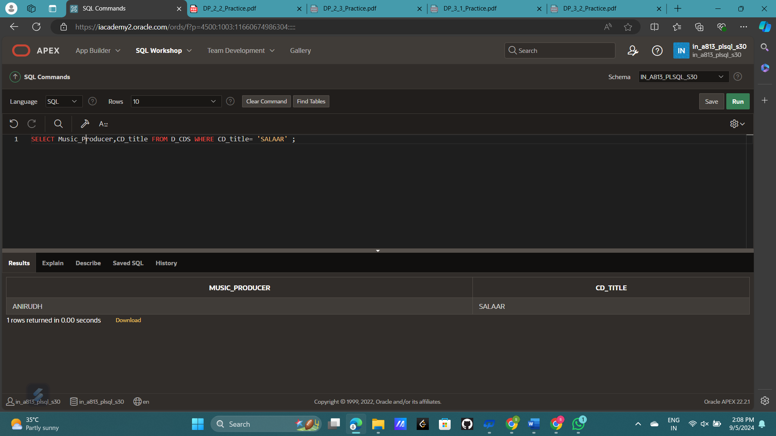

5. The manager of DJs on Demand would like a report of all the CD titles and years of CDs that were produced before 2000.

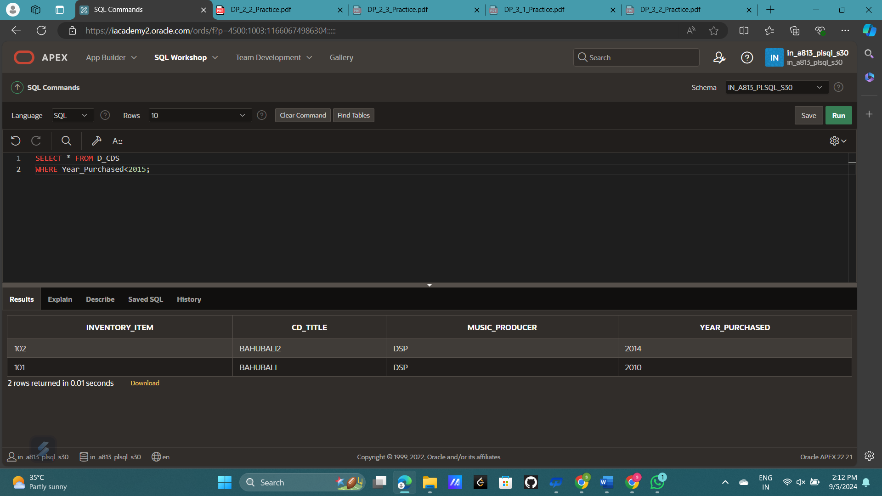

6. Which values will be selected in the following query? SELECT salary FROM employees WHERE salary < = 5000;

a. 5000

b. 0 - 4999

c. 2500

d. 5

ANS:- ALL OF THE ABOVE

For the next three questions, use the following table information:

TABLE NAME: students

COLUMNS: studentno NUMBER(6)

fname VARCHAR2(12)

lname VARCHAR(20)

sex CHAR(1)

major VARCHAR2(24)

7. Write a SQL statement that will display the student number (studentno), first name (fname), and last name (lname) for all students who are female (F) in the table named students

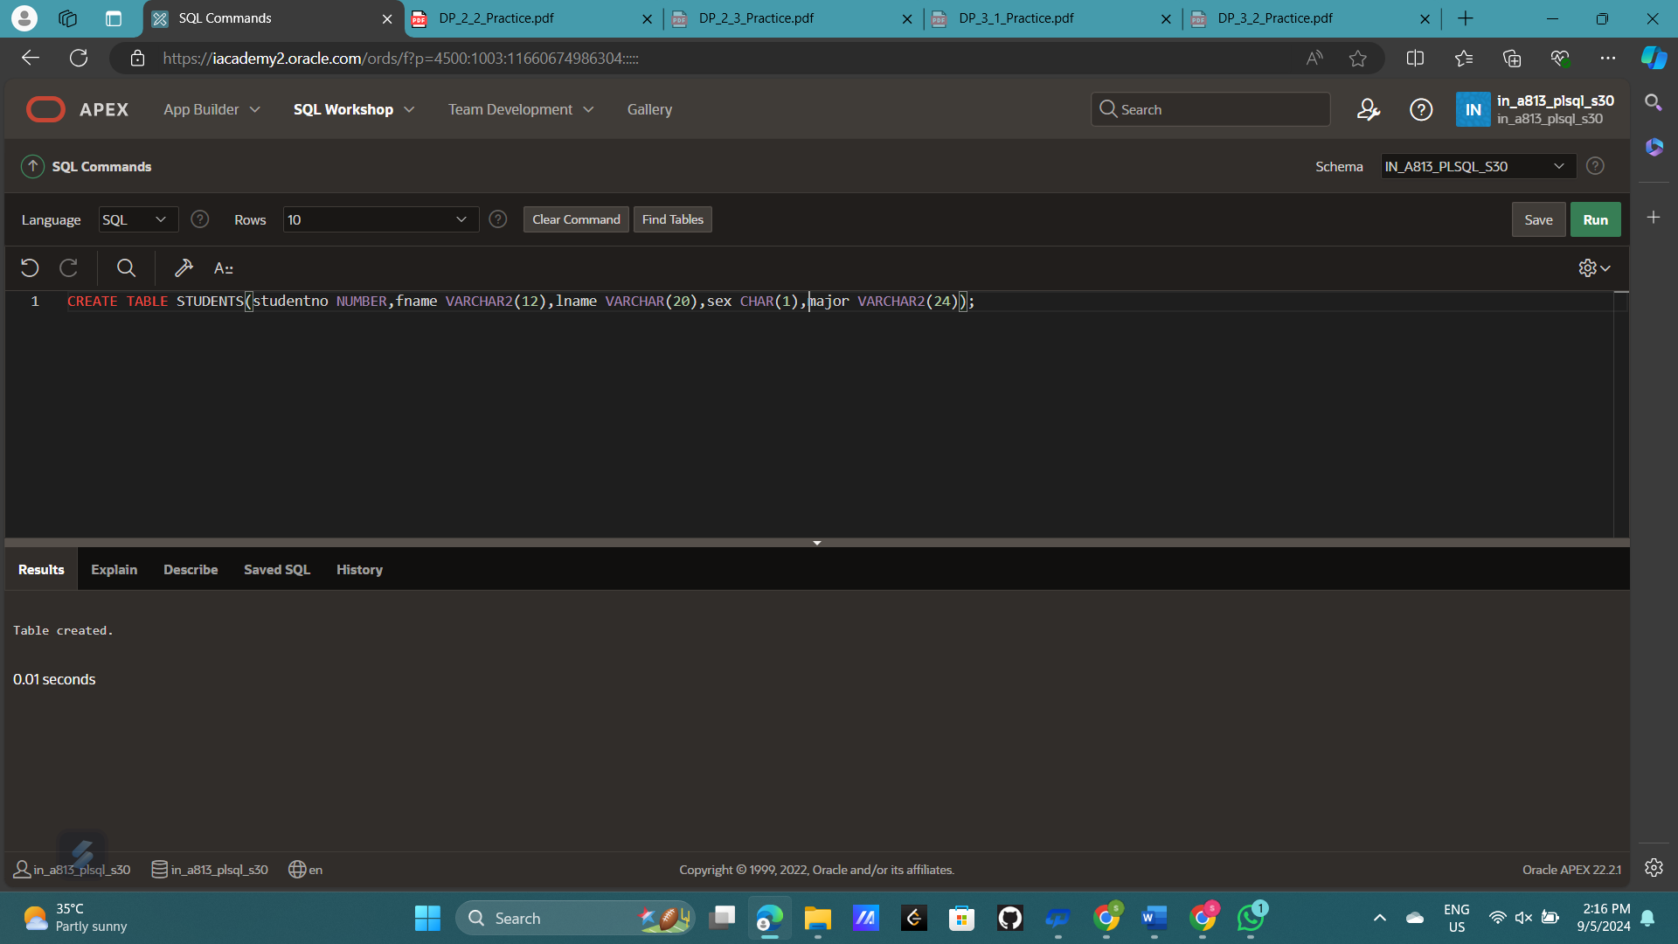

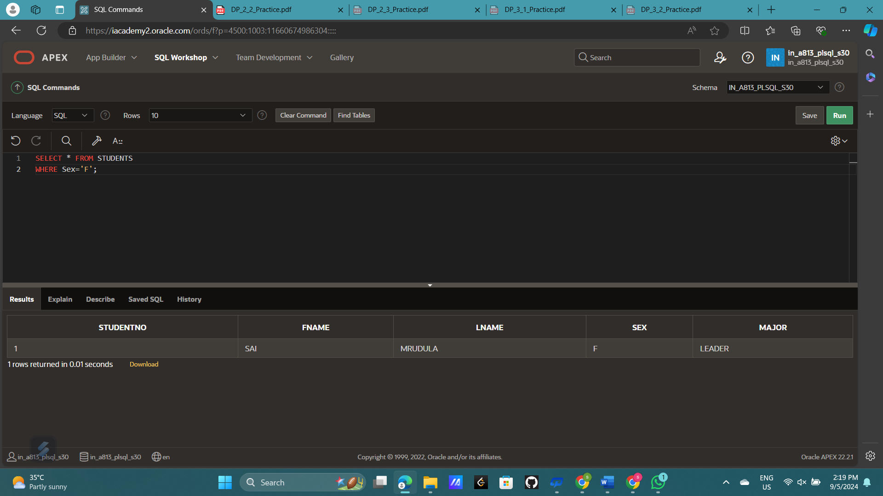

8. Write a SQL statement that will display the student number (studentno) of any student who has a PE major in the table named students. Title the studentno column Student Number

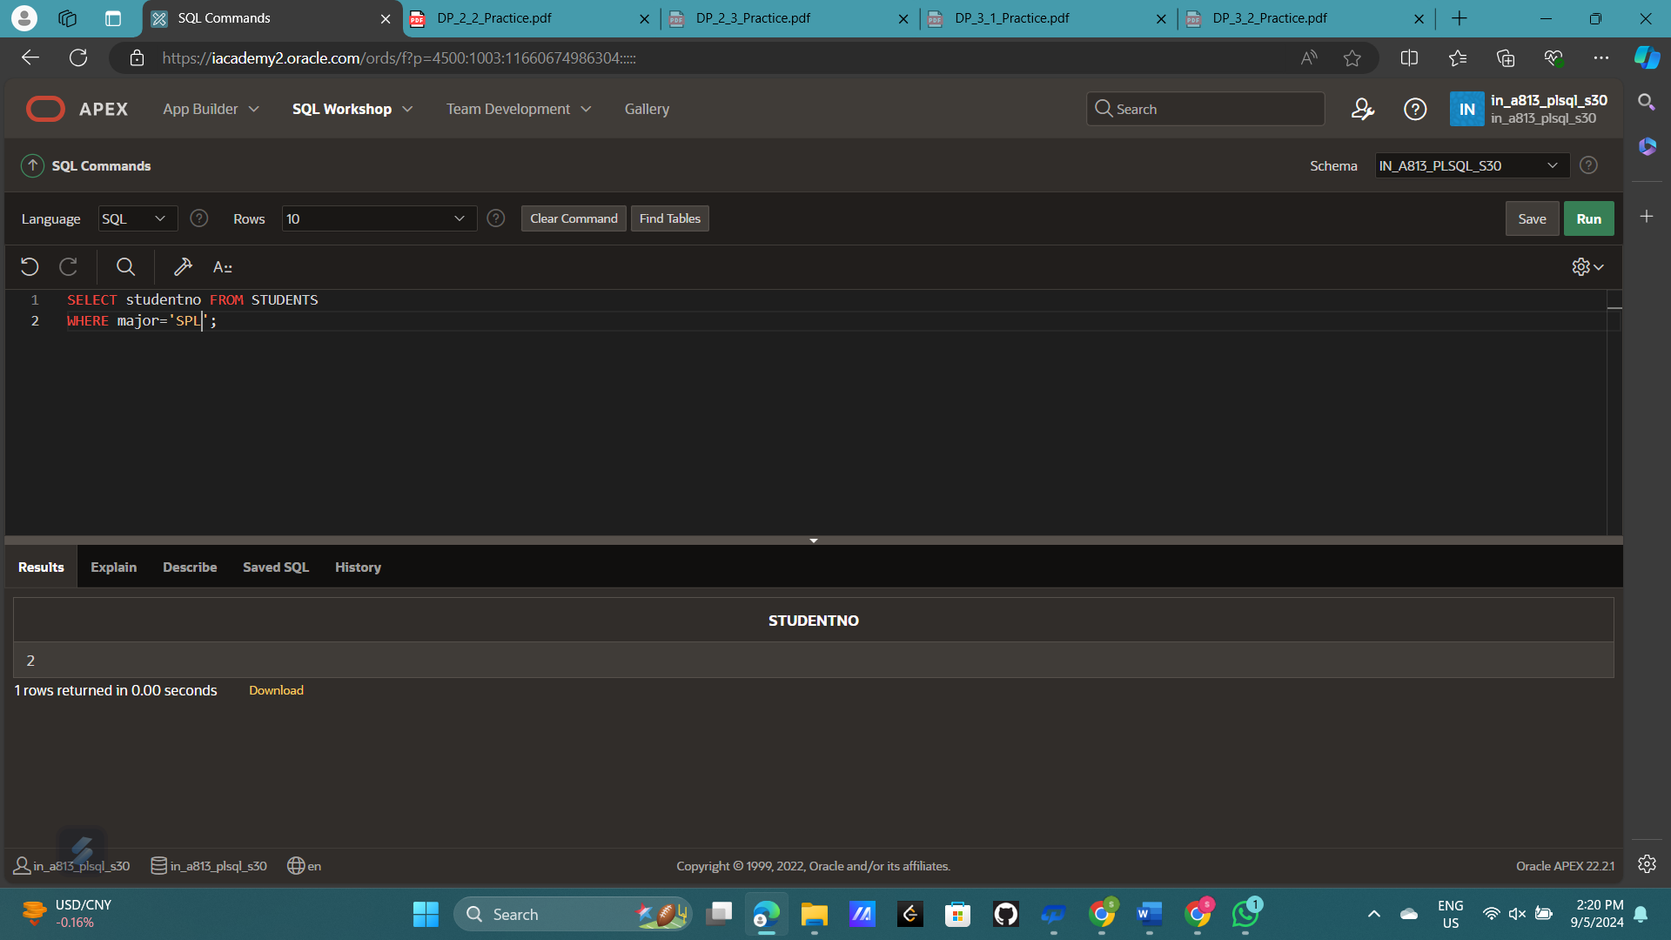

9. Write a SQL statement that lists all information about all male students in the table named students.

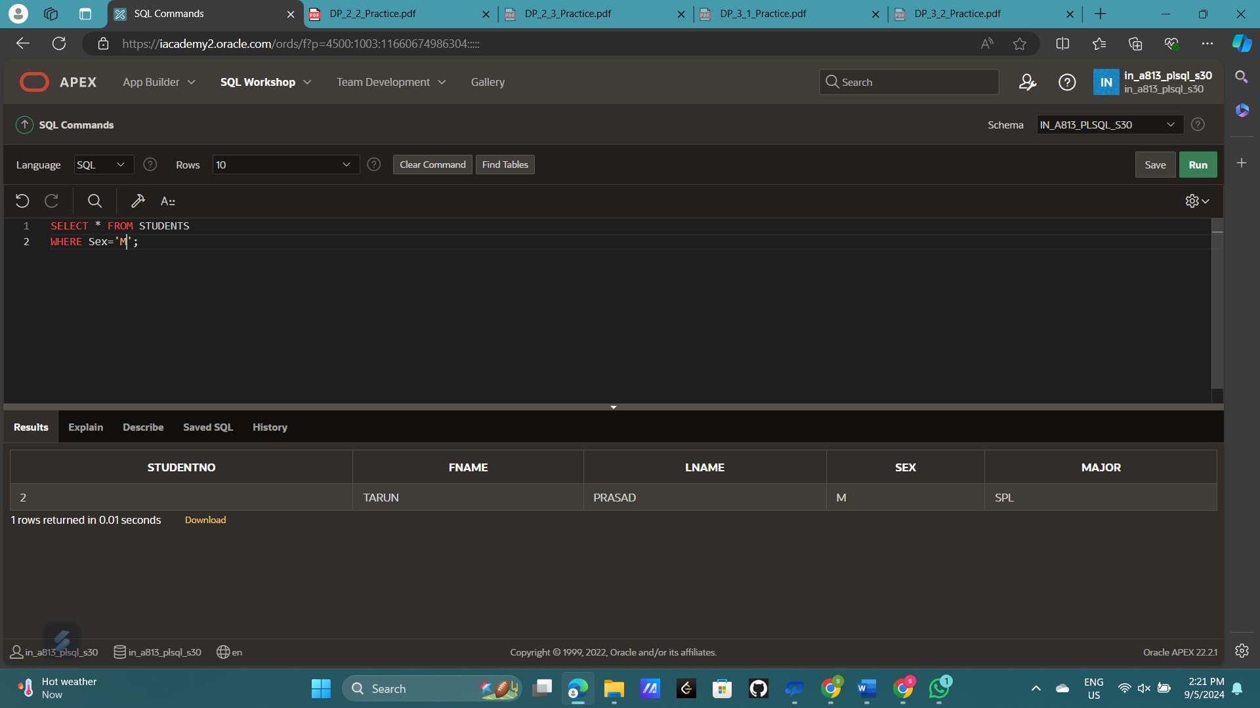

10. Write a SQL statement that will list the titles and years of all the DJs on Demand CDs that were not produced in 2000

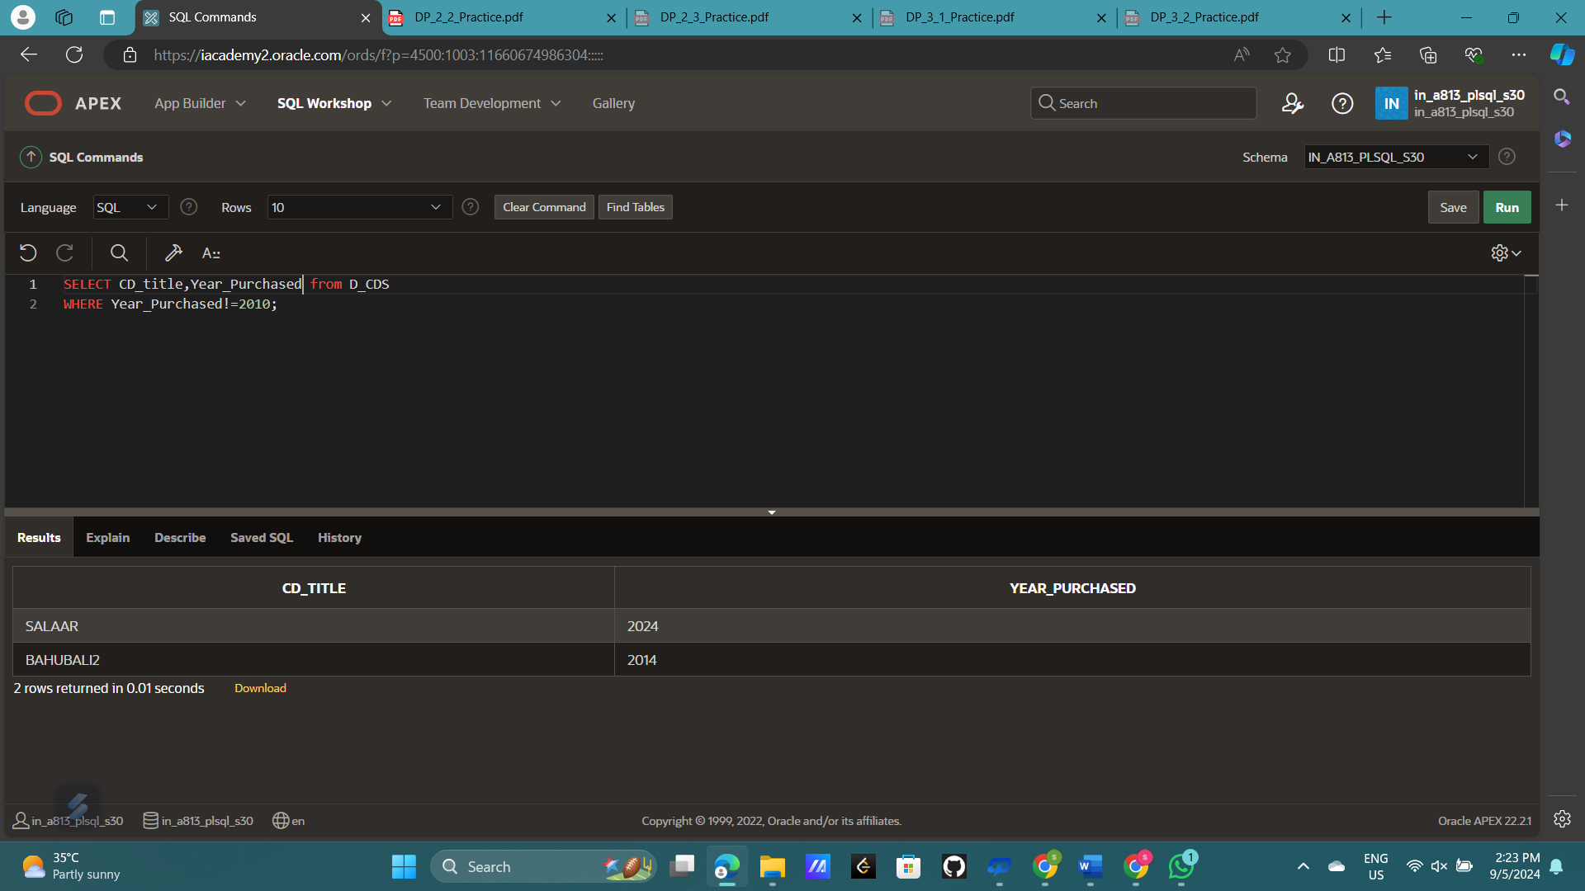

11. Write a SQL statement that lists the Global Fast Foods employees who were born before 1980

